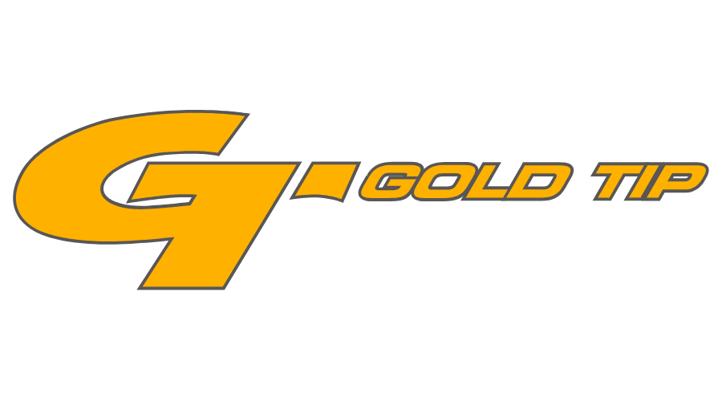

FOR IMMEDIATE RELEASE
Team Gold Tip Takes Home Triple Crowns and Gold Medals
at IBO World Championship, US Open
Levi Morgan, Tim Gillingham End Record-Breaking Seasons with Impressive Wins
FLORA, Miss. – September 3, 2021 – Gold Tip, an industry leader in carbon arrows and bolts, is celebrating recent team wins, including taking home two golds at the IBO World Championship (August 5-8 in Seven Springs, Pennsylvania), and gold at the USA Archery Target Nationals and U.S. Open (August 18-21 in Richmond, Virginia). In addition, the Triple Crown awards for all three IBO Men’s Pro classes were won by Gold Tip Shooters this year.
At the IBO World Championship, Gold Tip shooter Levi Morgan had an incredible come-from-behind win in the Men’s Pro class, where he hit the final eight 11 rings in a row to take home the top prize. Likewise, the Pro Bowhunter podium was swept by Gold Tip and Bee Stinger shooters, with Jonathan Smith taking home top honors, John Ball in second place and Justin Ertel in third place. In the Senior Pro class, Gold Tip shooters Jeff Kirkland and Tim Gillingham took third and fourth, respectively.
The IBO’s Triple Crown culminated with all three of the Men’s Pro Classes being won by Gold Tip shooters. The IBO Triple Crown is awarded to the top points leader in every class over the three tournaments of the IBO National Triple Crown. Levi Morgan dominated the Men’s Pro Class, Tim Gillingham reigned supreme in the Senior Pro Class and the Pro Hunter Class was topped by longtime Gold Tip staffer Matt Bressler.
At the USA Archery Target Nationals and U.S. Open, Team Gold Tip continued to shine, with Tim Gillingham taking gold in the Compound Master Men’s event. With a stacked field of experienced shooters, Gillingham went head-to-head as a top four seed in the medal matches to earn his first-place finish. In the process, Gillingham took home two world records in the Master Class. This extends his tally to three new world records for the year, each accomplished with his Gold Tip Pierce shafts and Bee Stinger Premier Plus bars.
About Gold Tip
Gold Tip, a Vista Outdoor Brand, is an archery manufacturer of the most innovative, durable and precise carbon arrows in the world. Every Gold Tip arrow is manufactured from the finest aerospace-grade materials, and built to meet the industry’s weight and straightness specifications. Gold Tip’s products are supported by a network of knowledgeable and friendly employees, dealers, and distributors. That’s why many of the world’s top professional archers depend on Gold Tip, and why bow hunters and archers claim that Gold Tip makes the toughest arrows they’ve ever shot. For news and product information, go to www.goldtip.com or follow us on Facebook at https://www.facebook.com/goldtiparrows/ and Instagram https://www.instagram.com/goldtiparrows/.

Contact: Matt Rice
Sr. Manager Media Relations
Gold Tip
(913) 689-3713
Matt.rice@VistaOutdoor.com

Product Requests: Will Folsom
Public Relations Associate
Swanson Russell
(402) 437-6404
willf@swansonrussell.com
###

